Fitness Rules & Regulations
* The nautilus, free weights and cardio equipment area available to participants 14 years and older
* Each person must sign in at the front desk before using the fitness floor
* NO food is allowed on the fitness floor
* All mats, dumbbells, and other equipment must be returned to their appropriate locations after each use.
* DO NOT drop the weights or bang them together
* Re-Rack your weights when you are done with your workout
* DO NOT rest on the strength training equipment when others are waiting
* Proper attire is required on the fitness floor – shirts and shoes are required – no open toed shoes are allowed
* Please wipe down equipment after each use
* There is a 20 minute time limit on all cardio when people are waiting
* Foul language and inappropriate behavior are NOT acceptable – all members must conduct themselves in an appropriate manner – failure to do so may result in membership revocation

Park District Office Hours
Mon, Tues, Thurs : 8 am – noon
4 pm to 7pm
Wednesday: 4 pm to 7 pm
Friday: 8 am – noon
3 pm to 6 pm
Saturday: 8:30 am – 11 am
Sunday: Closed All Day

Members with active memberships and a Prox Card have access to the fitness center: 5 am – 10 pm
Tremont Area Park District

Programs, Parks, Lakes, Rentals
Fishing and Pool

For more information visit our website
www.tremontpark.org

Fitness Center
- Hours of Operation
- Rules and Regulations
- Membership Types
- Membership Rates
- Group Fitness Classes

22522 IL Route 9
Tremont, IL 61568
(309) 925-3811
www.tremontpark.org
tapdfacres@gmail.com

Membership Includes
- Use of cardiovascular equipment which includes treadmills, elliptical, bikes, Jacob’s ladder, endless rope, rowing machine and stair stepper
- Use of strength training equipment, free weights and machines
- Group exercise classes are FREE for members
- When not staffed, members agree to work out at their own risk

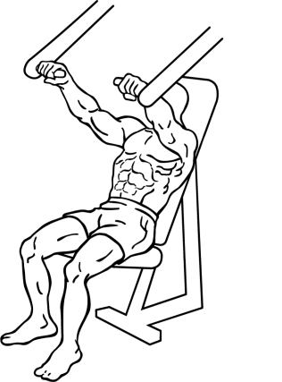

Regular Membership Rates
$25.00 – 1 Month Individual Membership

You may add an additional family member(s) from your household for just $5.00 each per month.

Purchase a 1 year membership and receive 1 month FREE

Payment forms: Cash, Check, Credit / Debit Card (please note: there is a convenience fee of 3% to use a credit / debit card)

Fitness Special

Check our website for the most up to date specials we have to offer!

www.tremontpark.org

Group Fitness Classes
PowerFlex: a full body – approximately 1 hour workout - using free weights & cardio step (as a bench) - each body part is exercised continuously for about 5 minutes with very little break in between groups - it is both a strength and aerobic workout

Spin: a fun fast paced 60 minute indoor cycling class

Tabata: short burst, high intensity workout that has fitness and weight loss benefits

Yoga: a discipline that utilizes postures and breathing techniques - this form of yoga offers a range of health benefits, as it encompasses all areas of mind, body and spirit

Group fitness classes are FREE to members
Non-members may pay $5.00 per class or purchase a 10-punch pass for $40.00
Check out our website for class date & time

